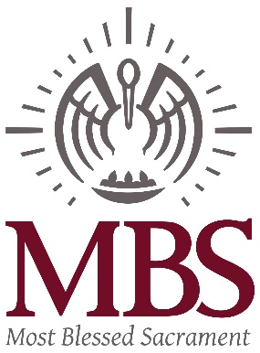
Frequently Asked Questions about the new MBS Full-Day PK-4
- The inaugural MBS PK-4 Class will begin with the 2018-2019 School Year and student attendance will follow the school calendar from August to May
- Students will follow a full day schedule
- The curriculum will align with the MBS Kindergarten curriculum to assist with readiness for a Kindergarten program
- Students must be four (4) by September 30, 2018.
- There will be a 10:1 Student: Teacher ratio, with a maximum of 20 students
- The lead PK-4 teacher will be certified, with a BS degree in Early Childhood Education.
- The school day is 7:15am – 3:15pm
- Extended Care is available for an additional fee.
- Students can bring a bag lunch from home or participate in the school lunch program for a fee.
- Students will wear the MBS school uniform.
- Students will attend Mass and participate in religious education.
- Students with current MBS siblings do have priority as it relates to admissions
- Applications will be time stamped. All admission criteria being equal, date and time of completed and submitted applications will be taken into consideration
- The tuition and fees for PK-4 are
Tuition is $5800 a year; registration is $350, tech fee is $100 and PK-4 fee is $75 PK-4 fee, snack fee and supply fee
- Students will nap

