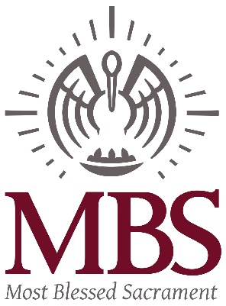

January 23, 2018
Re: MBS Athletics Update
Dear MBS Families,
I wanted to share some news about MBS Athletics. This year has been a fantastic year for our athletic program. We have had record numbers of student athletes, we added a Middle School Soccer team, our Cross Country Team set records, and our 7/8 Grade Football team won the St. Michael Warrior Bowl and the Catholic High Bruin Bowl. Wow! What a great time to be a Pelican.
There have also been some changes within our Athletic Program. Mike Connors presented us with his resignation on January 7. His resignation as Assistant Athletic Director was effective January 15. We appreciate Mike for his hard work and dedication to MBS Athletics during his short time with us. Our prayers and good wishes go with him.
Mike’s resignation presented Father Phil and me with the opportunity to restructure the administration of MBS Athletics. After consultation with Christine Rabalais, Athletic Director, she will now oversee MBS Parish and School Athletics. That means Christine will distribute and collect all forms, create all practice and game schedules, secure all coaches, conduct all coaches meetings, and oversee all of the other administrative duties associated with MBS Athletics. Christine will also be working some of the events. This should be a seamless change. When Christine is not available to work events, site supervisors from within the MBS Faculty or MBS Family will oversee scheduled events.
Andrew Button has been hired to run both the Football Field and Gym Concession Stands with the support of our faithful volunteers. He will also keep up with concession inventory and work events as needed.
We will soon launch an MBS Athletic Council. The mission of this council will be to support MBS Athletics, MBS Families and the MBS Athletic Director. Three of the vital roles the council will play will be to support volunteering within MBS Athletics, help guide and inform the direction of future athletic facility maintenance and upgrades and help with formulating a process to register and pay for athletics online.
Christine and I are working hard on communicating efficiently and effectively with all athletic stakeholders. To better serve MBS, Christine will have scheduled office hours from 9am – 11am on Mondays, Tuesdays, and Wednesdays, when school is in session. If you need Christine for any reason, please contact her during these hours or email her to schedule a meeting. Christine’s email address is crabalais@mbsbr.org. Christine will continue to keep the Athletic website current with updated timelines, schedules and forms. We will also be working together to advertise athletic opportunities and events more effectively in our school newsletter, The Pelican Express.
Lastly, we remind all of you that MBS Athletic employees are employed part time. Much of the success of MBS Athletics is due to our volunteers. By joining an MBS team, you agree to support MBS Athletics with volunteer hours. Thank you for doing your part in making our athletics program successful.
If you have any questions or concerns about MBS Athletics, please contact me.

Sincerely,
Cheri M. Gioe, Principal
cgioe@mbsbr.org
225-751-0273

