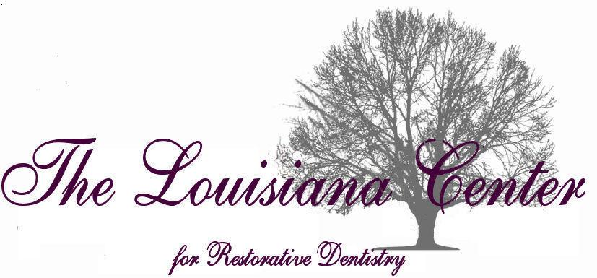

Curriculum Vitae

Nelson P. Daly DDS, FAGD, AFAAID, FACD, FICOI, FADI

June 20, 2017

ADDRESS: 15318 Campanile Ct.
Baton Rouge, La. 70810
(225) 767-1770
drd@drsdaly.com

OFFICE: 4450 Bluebonnet Blvd, Suite B
Baton Rouge, La. 70809
(225) 927-5248
Drsdaly.com

FAMILY: Sally B. Daly DDS
Married 5-19-95
Child: Lesley A. Wolfe

4450 Bluebonnet Blvd, Ste B Nelson P. Daly DDS 225-927-5248
Baton Rouge, LA 70809 Ann B. Uzee DDS www.drsdaly.com

EDUCATION:

Catholic High School, Baton Rouge, La. – graduation 1973

LSU Baton Rouge, La. – graduation with B.A. 1984

UNO New Orleans, La. – graduation with B.S. 1989

LSU School of Dentistry, - graduation with DDS 1993

Veteran’s Administration Hospital- General Practice Residency, completed 1994

Medical College of Georgia/AAID Maxi Course in Dental Implantology, completed 2008

Advanced Cardiac Life Support- completed first time 2009, and continual since

Advanced Dental Implant Studies in Atlanta Georgia- 2008 to present

LICENSURE:

State of Louisiana- DDS, current

State of Louisiana- Adult Oral Anesthesia/Analgesia- Personal

State of Louisiana- Adult Oral Anesthesia/Analgesia- Office

Louisiana Board of Pharmacy- License Class 08

U.S. DEA, Controlled Substance Registration

PRIVATE PRACTICE:

4450 Bluebonnet Blvd, Suite B, Baton Rouge, La. since February 2005.

6509 Government St. Suite B, Baton Rouge, La. September 1994 to February 2005.

ACADEMIC APPOINTMENTS:

Adjunct Professor- LSUSD, 2005-2006.

PROFESSIONAL ORGANIZATIONS AND OFFICES:

Greater Baton Rouge Dental Assoc. Past President, Board Member, and Delegate to LDA.

Louisiana Dental Assoc., State President (2014), Past Director to LDA for Greater Baton Rouge Dental Assoc- 2007-2012, and past LDA State Chairman- Membership- 1997-2007.

American Dental Assoc., Committee for New Dentist- 12 district representative, 1999- 2003, Alternate Delegate for Louisiana 2014, 2015, 2016, 2017

LSU School of Dentistry Alumni Assoc, past Chairman 2009-2011, Board member 2004-2011.

LSU School of Dentistry External Advisory Board member, 2014 to present

New Orleans/LDA Dental Conference committee member 2014, to present

Academy of General Dentistry member 1993 to present

American Academy of Implant Dentistry, member 2008 to present

International Congress of Implantologists, member to present

Academy of Dentisty International, member 2002 to present

Partner/lecturer- Georgia Maximus Program (Implant Dentistry) 2015, 2016

Advanced Dental Implant Studies- founding member 2009 to present.

Baton Rouge Community Clinic, founding member, board of directors, past President.

Baton Rouge Study Club, founding member to present

Baton Rouge CEREC Study Club, founding member

Donated Dental Services, member dentist/provider

Commisioner La. Medical Disclosure Panel 2015 to present

SPECIAL HONORS AND AWARDS:

LSUSD Alumni Assoc Leadership Award 1993

LDA New Dentist Award 2000

LSUSD Alumnus of the Year 2017

Associate Fellow American Academy of Implant Dentistry 2012

Fellow Academy of General Dentistry 2010

Fellow American College of Dentists, 2016

Fellow International Congress of Oral Implantologists Jan. 2016

Fellow Academy of Dentistry International 2002

Certification of Appreciation LSU Health Sciences, Leadership Circle 2015

Certification of Appreciation LSU Health Sciences, Sustaining Partner 2015

LSUSD Mentor Program 2005-2009

LDA Service Award for State Chairman Membership and Dental Practice 1998-2008

Founder LDA/Foundation Fishing Rodeo 2001 to present, and Sponsor for LSU dental students to attend

LECTURES:

Greater Baton Rouge Hygiene Association- Dental implants for the hygienist
Dentistry for the medically compromised patient

Georgia Maximus Implant program- Suturing techniques for implant/graft surgery

Baton Rouge Study Club- Dental implants 101

Greater Baton Rouge Lupus Society- Dentistry for the Lupus Patient

EMPLOYMENT:

Our Lady of the Lake Hospital, Baton Rouge, La, Surgical Tech, 1980-1984

Doctor’s Hospital of Jefferson, Metairie La, Surgical Tech, 1984-1989

Lakeside Shopping Court, (Lacoste Gentle Dental) Metairie La. 1995 to 1997.

Private Practice General Dentistry Baton Rouge La since 1994

CHARITY:

Ecudent dental mission trip volunteer in Ecuador

La. Mission of Mercy volunteer

REFERENCES:

Upon request.

INTERESTS:

Scuba diving, with certifications for open water, advanced, rescue, nitrox, and master level.
Offshore fishing, Past LSU tiger band member- playing music, target shooting

