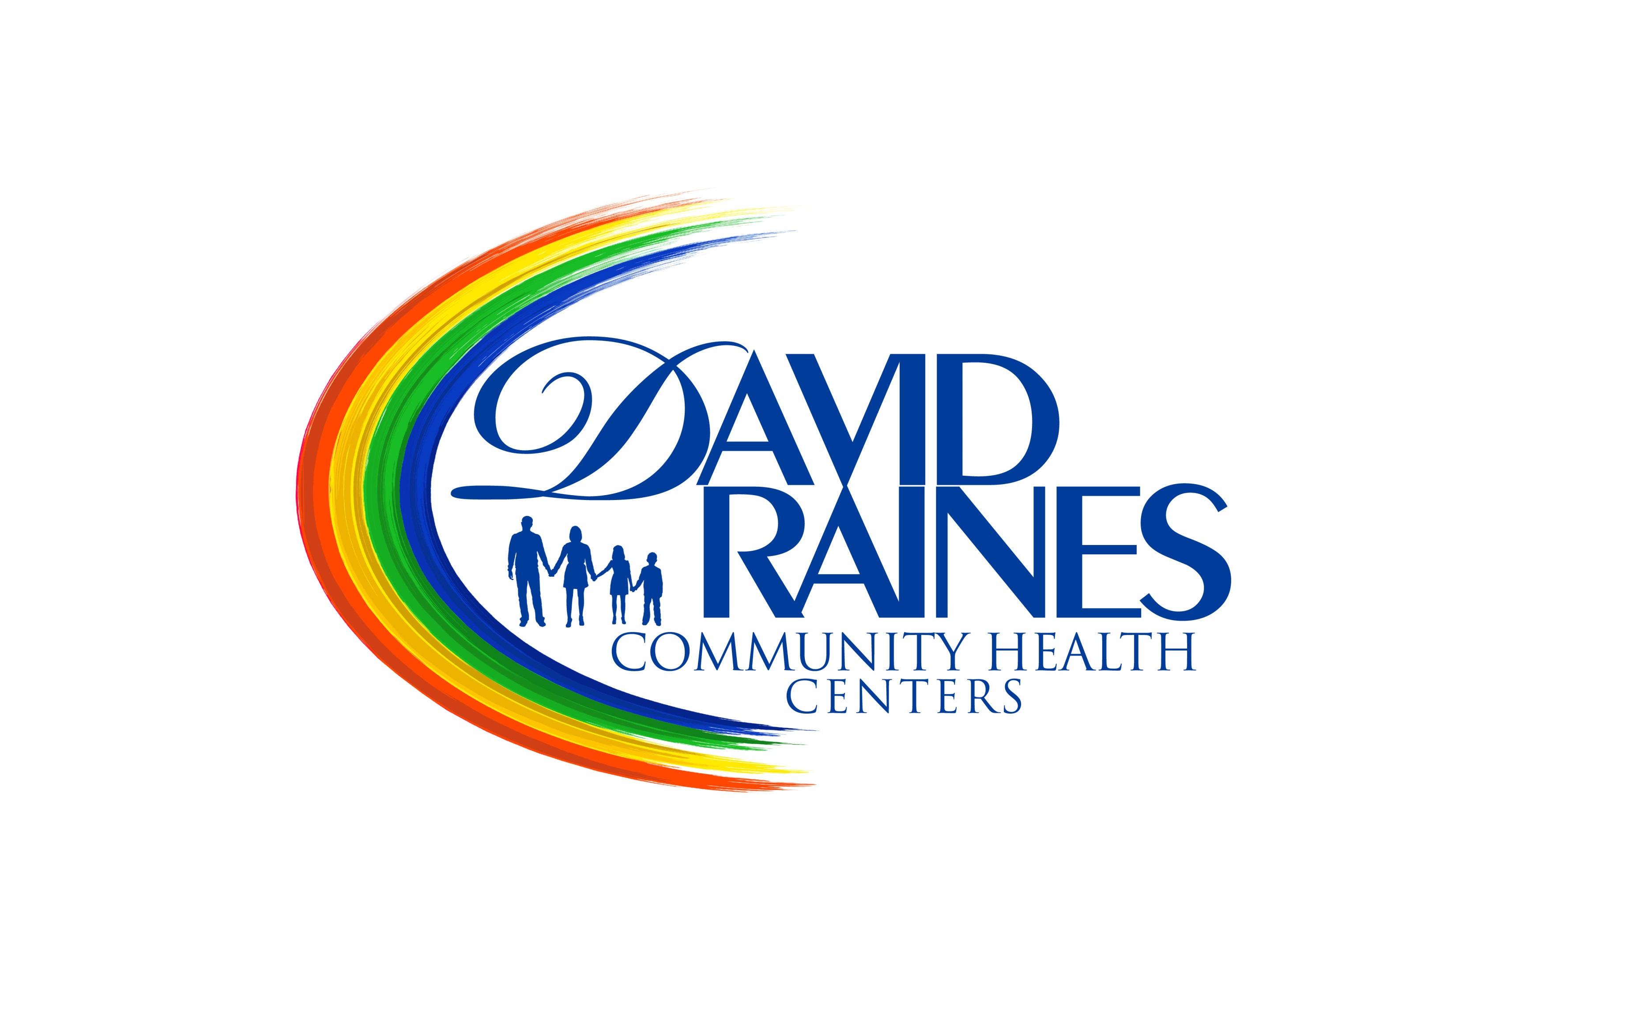 David Raines Community Health Centers
Job Success Profile

Chief Medical Officer
The Chief Medical Director is a strategic leader creating a plan for aligning people, processes and values that support and further the organization’s mission. Under the administration of the Chief Executive Officer, the CMO is responsible for David Raines Community Health Centers’ compliance with all clinical medical policies, directives, rules, regulations and clinical performance standards of the state, the federal government, and accrediting bodies and serve as the organizations ultimate authority on medical issues. The CMO scopes of responsibilities include population community health, behaviour health and integrated care for the underserved communities. The CMO will model behaviours consistent with the published values and the Code of Conduct of DRCHC.

Department: Medical | Job Status: Full Time
FLSA Status: Non Exempt | Reports To: Chief Executive Officer
Grade/Level: | Amount of Travel Required: 20%
Work Schedule: Monday-Friday, 7am-6pm | Positions Supervised: Medical Staff

Essential Skills

• Six years of experience in a clinical, academic or administrative capacity required
• Must have a strong community health/public health orientation; be experienced in patient care management
• Current DEA and BLS certification
• Work experience in a primary care setting with Pediatric, Adolescent, Adult and Geriatric patients
• Management experience and proficiencies in a clinical setting
• Must be able to use protocols, guidelines and benchmarks to implement policies and develop quality improvements while utilizing best practices
• Excellent organizational skills, leadership skills, and excellent verbal and written communication skills
• Proficiency using EHRs systems and other computer programs
• Full knowledge of the nineteen requirements of FQHCs
• Must be able to effectively handle multiple tasks and priorities in order to meet deadlines and
act as Clinical Lead;
- provide direct care to patients within the Scope of Practice for which provider is licensed;
- provide direct care to clients/patients to support medical needs of the target population;
- manage patient care under Best Practices, Uniform Data System recommendations, and as prescribed to maintain accreditation;
- identify and prioritize medical decision making with a fiscally minded approach to care;
- complete thorough documentation of visits and medical orders to support billing charges;
- complete billing components of visit to optimize revenue within dictated times frames;
- participates in webinars, conferences and meetings relative to assigned program and Primary Care;
- report to funders as directed in reports, emails or teleconferences as Chief Medical Officer;
- support Credentialing and Privileging decision making of medical providers and allied health professionals and participates as a liaison to the DRCHC Health Center’s Board of Directors;
- participate in agency Quality Improvement/ Quality Assurance program to meet Clinical Measures requirements for accreditations;
- Oversees development of Best Practices initiated by Quality Improvement/ Quality Assurance programming;
- participates in Operations, Management, Providers meetings for the Agency;

Additional Functions

- Works with the CEO in coordinating clinical/administrative issues.
- Develops principles of practice for the medical department.
- Participates in the credentialing of the medical staff.
- Develops and updates the center’s OSHA compliance program.
- Serves as a Laboratory Director for in-house lab testing.
- Supervises in clinical triage of patients.
- Initiates staff, as well as patient education.
- Participates in the recruitment/retention of the medical staff.
- Chairs the Performance Improvement Committee.
- Helps to develop the Health Center’s Health Care Plans.
- Acts as a leader of patient advocacy.
- Develops the on-call scheduling of physicians.
- Develops Health Care protocol for the Medical Staff.
- Attends Board meetings and provides clinical input.
- Provides after-hours emergency and hospital care on a rotating basis with other staff Physicians.
- Provides direct medical care to clinic patients, including examination, diagnosis and treatment according to established policy and protocol.
- Provides in-patient care via local hospital.
- Accepts emergency calls as scheduled or as necessary.
- Meets with other members of the staff and participates in the planning and implementation of health service improvements.
- Frequent contact is maintained with the Medical Director to whom he/she is responsible.
- Performance is evaluated in terms of patient care quality, by conference, and by observation.
- Serves on the health services program committee to review program activities.
- Reviews labs and recalls cases with abnormal labs.
- Calls patients at home to follow up on cases.
- Takes after hour calls once or twice per month.
- Provides after hours emergency and hospital care on a rotating basis with other staff Physicians.

Resource Management Skills

1. Help to develop, lead and perpetuate the organization’s strategy and mission; help to ensure activities are value-added and aligned with community need.

2. Lead and direct the development, implementation, and monitoring of quality medical care and ancillary services, programs and initiatives. Ensure that the delivery of all health care meets or exceeds:
a. the needs and satisfaction of patients served
b. all organizational and professional standards
c. all clinical outcomes and related expectations
d. all productivity standards, goals, and expectations
e. all financial metrics associated with the efficient, cost-effective delivery of health care services.

3. Champion the organization’s quality improvement initiatives. Ensure metrics for clinical outcomes are consistently reviewed and the organization is provided clear guidance and direction affecting ongoing improvements in the quality of care. Focus will ensure improving patient experience, reducing expenditures and improving health outcomes as well as working toward patient-centered medical home recognition. The organization will continue to work toward and embrace future focused value-based payment methodology.

4. Provide leadership and direction related to clinical collaboratives, studies, programs, or research related initiatives that improve the lives of our patients as well as the communities in which they live.

5. Manage all functional areas within budgeted guidelines.

6. Personally provide care to patients, as feasible (following established standards of DRCHC’s staff physicians). Directly influence improvements in patient well-being through accurate and timely diagnosis and delivery of relevant, high quality medical care. Ensure the delivery of competent, accurate medical care and treatment to all patients as assigned.
Operational Excellence

7. Ensure all medical staff members are properly contracted, qualified, directed, and motivated to provide high quality services and care to patients.

8. Ensure all patient records and related documentation are maintained current and consistent with best practices in the health care field, as well as within all relevant laws and regulations. Ensure the organization meets or exceeds all governmental, regulatory and accreditation standards in all areas of day-to-day operations.

9. Provide advice and counsel to all clinical personnel on matters related to clinical care, patient grievances and related issues. Minimize risk and exposures to the organization by monitoring trends, managing issues, coaching staff, and ensuring compliance with all clinical protocols and QA guidelines.

Relationship Management
10. Manage and ensure favorable relationship within the organization’s leadership team. Provide leadership, insights, solutions, and support to all other functions with the organization.

11. Manage and ensure favorable, collaborative relationships within and among all clinical staff. Establish effective communication between leadership and clinical staff. Develop a culture of health care professionals open and willing to accept an integrated approach to the delivery of services.

12. Manage and ensure favorable relationships with federal partners (HRSA [BPHC and HAB] and CDC), local and state health departments, as well as other accreditation and related resources vital to the organization’s continued success.

13. Establish positive working relationships with area hospitals, clinics, medical providers and specialists, regulatory
Desktop Computer Skills

- Internet - Using a computer application to access resources online.
- Navigation - Using scroll bars, a mouse, and dialog boxes to work within the computer's operating system. Being able to access and switch between applications and files of interest.
- Databases - Using a computer application to manage large amounts of information, including creating and editing simple databases, inputting data, retrieving specific records, and creating reports to communicate the information.
- Presentations - Navigating the Internet to find information, including the ability to open and configure standard browsers; use searches, hypertext references, and transfer protocols; and send and retrieve electronic mail (e-mail).
- Spreadsheets - Using a computer application to enter, manipulate, and format text and numerical data; insert, delete, and manipulate cells, rows, and columns; and create and save worksheets, charts, and graphs.
- Word Processing - Using a computer application to type text, insert pictures, format, edit, print, save, and retrieve word processing documents.
- Medical software
- Word processing software
  - Microsoft Word
  - Word processing software
- Spreadsheet software
  - Spreadsheet software
  - Microsoft Excel
- Calendar and scheduling software
  - Calendar software
- Electronic mail software
  - Email software
- Internet browser software
  - Web browser software
- Office suite software
  - Microsoft Office software

Physical Demands
- Ability to safely and successfully perform the essential job functions consistent with the ADA, FMLA and other federal, state and local standards, including meeting qualitative and/or quantitative productivity standards.
- Ability to maintain regular, punctual attendance consistent with the ADA, FMLA and other federal, state and local standards
- Must be able to lift and carry up to 50 lbs
- Position requires standing 2/3 of the time, walking 2/3 of the time, requires sitting 2/3 of the time, use of hands to finger, handle or feel 1/3 of the time, reach with hands and arms under 1/3 of the time, stoop, kneel, crouch or crawl under 1/3 of the time, talk or hear over 2/3 of the time.

- s
Working Conditions
Physical Requirements
- Work is performed primarily in medical offices. Work is often performed in stressful situations with competing deadlines. The noise level in the work environment is usually quiet in office settings and moderate in other situations.
- Work may require evening and weekend assignments that require physical presence outside of 8am-5pm business hours.
- May be required to travel to other health centers to partner with providers in case management.
- May be required to attend conference and training sessions within Louisiana or out-of-state locations.
- May be occasionally required to travel to outside donors, customers, vendors or suppliers.

- s
Education/Experience Qualifications
Physical Requirements
- Must be board certified or residency trained as defined by the respective specialty board or organization.
- Must be licensed to practice in the State of Louisiana.
- Must be available to work after hours and weekends as required

Chief Medical Officer
David Raines Community Health Centers
Job Success Profile Acknowledgement Form
David Raines Community Health Centers has reviewed this job description to ensure that essential functions and basic duties have been included. It is intended to provide guidelines for job expectations and the employee's ability to perform the position described. It is not intended to be construed as an exhaustive list of all functions, responsibilities, skills and abilities. Additional functions and requirements may be assigned by supervisors as deemed appropriate. This document does not represent a contract of employment, and the Company reserves the right to change this position description and/or assign tasks for the employee to perform, as the Company may deem appropriate.

I have reviewed this job description and I understand all my job duties and responsibilities. I am able to perform the essential functions as outlined. I understand that my job may change on a temporary or regular basis according to the needs of my location or department without it being specifically included in the job description. If I have any questions about job duties not specified on this description that I am asked to perform, I should discuss them with my immediate supervisor or a member of the Human Resources staff. I further understand that future performance evaluations and merit increases to my pay are based on my ability to perform the duties and responsibilities outlined in this job description to the satisfaction of my immediate supervisor.

David Raines Community Health Centers (DRCHC) provides equal employment opportunities (EEO) to all employees and applicants for employment without regard to race, color, religion, gender, sexual orientation, gender identity or expression, national origin, age, disability, genetic information, marital status, amnesty, or status as a covered veteran in accordance with applicable federal, state and local laws. DRCHC complies with applicable state and local laws governing non-discrimination in employment in every location in which the company has facilities. This policy applies to all terms and conditions of employment, including, but not limited to, hiring, placement, promotion, termination, layoff, recall, transfer, leaves of absence, compensation, and training. DRCHC expressly prohibits any form of unlawful employee harassment based on race, color, religion, gender, sexual orientation, gender identity or expression, national origin, age, genetic information, disability, or veteran status. Improper interference with the ability of DRCHC employees to perform their expected job duties is absolutely not tolerated.

I have received a copy of the job description for my position. I have discussed any questions I may have had about this job description prior to signing this form.
____________________________________ _______________________________
Employee Signature Date Signed
___________________________________
Employee’s Printed Name

