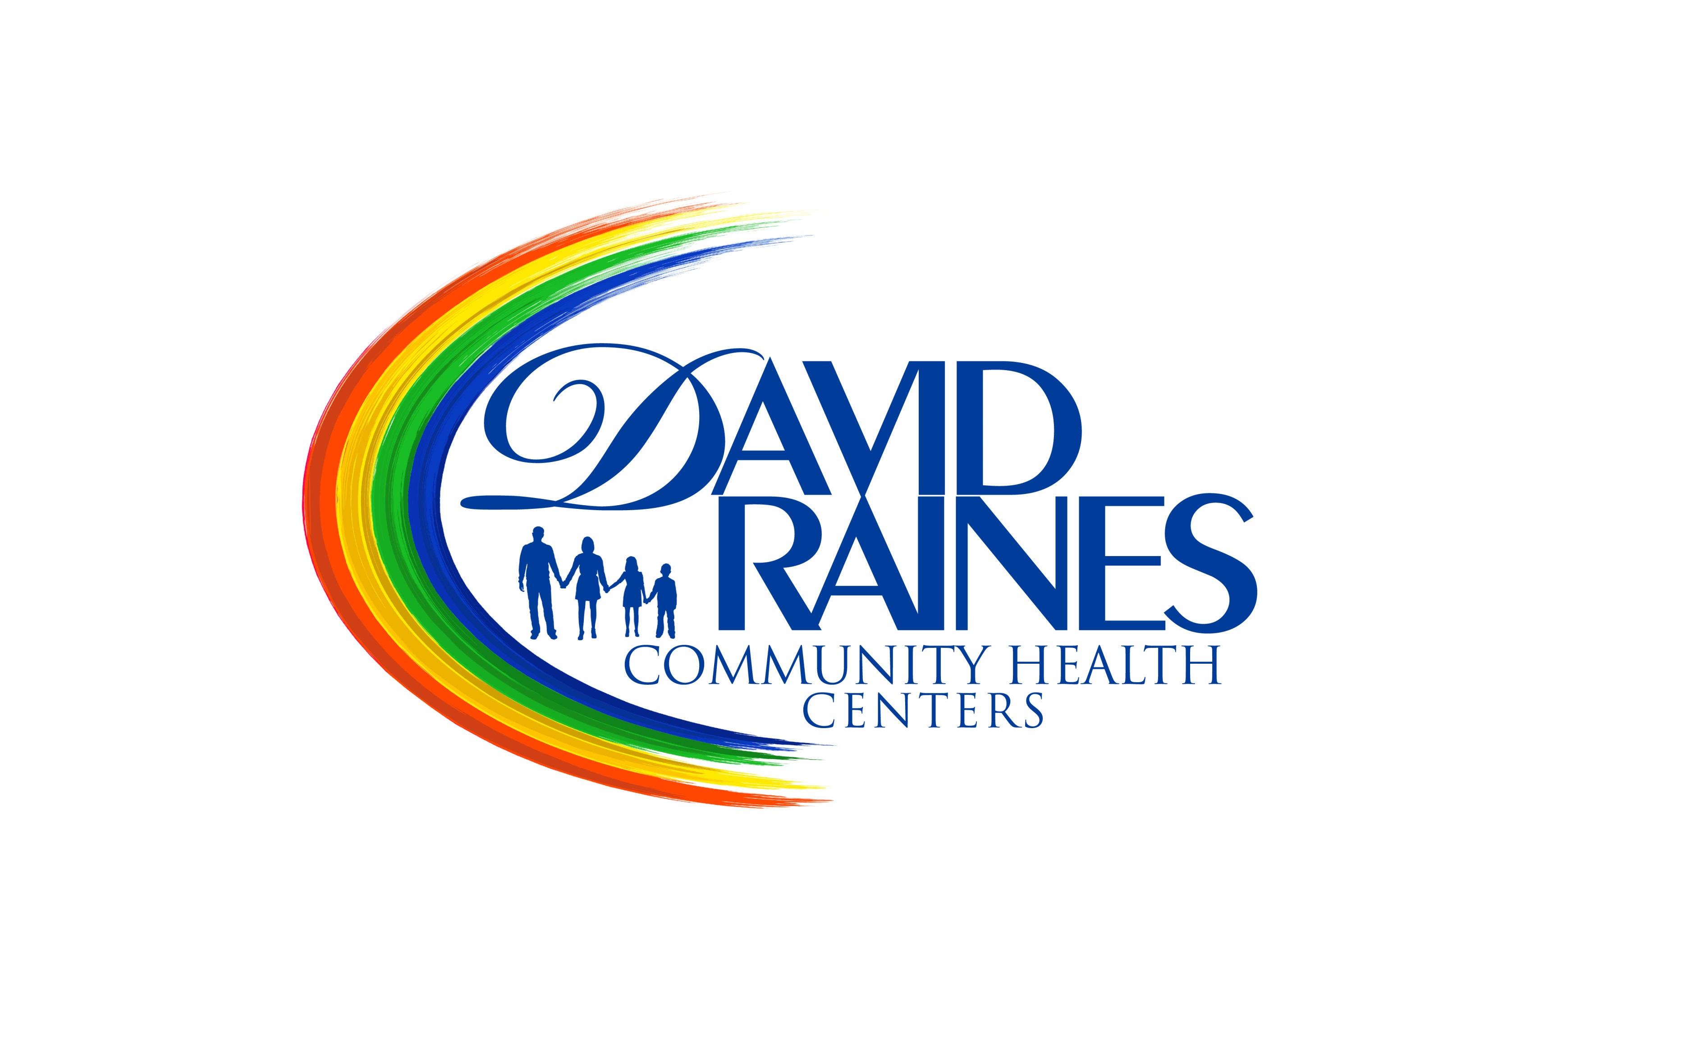 David Raines Community Health Centers
Job Success Profile

Nurse Practitioner
The Nurse Practitioner works under the supervision of the Medical Director and in close coordination with the other Health Center personnel. The NP provides medical care to all clinic patients, to include examination, diagnosis and treatment, with referrals to specialists or hospitals where indicated

Department: Medical | Job Status: Full Time
FLSA Status: Non Exempt | Reports To: Medical Director
Grade/Level: Master of Science | Amount of Travel Required: 20%
Work Schedule: Monday-Friday, 7am-6pm | Positions Supervised: None
Essential Skills

- Provides medical care to clinic patients including examination, diagnosis and treatment according to established policy and protocol, under the supervision of physicians.

- Meets with other members of the staff and participates in planning and implementing health services improvements.

- Frequent contact is maintained with the Medical Director to whom he/she is responsible.

- Adheres to the standards of medical practice; is responsible for treatment diagnosis, referrals, consultation and assist in medical education for both patients and center staff.

- Counsels with patients regarding medical and other problems, which might affect the patients’ health.

- Documents each and every patient visit in their medical record.

- As a member of the health team, is an example in attitude toward patients and staff, performing duties with respect to the dignity, confidentiality and modesty of patients.

- Must be available to rotate on occasion, as may be necessary, to other DRCHC sites (Bossier, Gilliam, Haynesville, Minden, or Shreveport).

- Provides comprehensive patient care with appropriate EHR documentation to all patients in compliance with Joint Commission and Patient Centered Medical Home standards of care.

Social Skills

- Being aware of others' reactions and understanding why they react as they do.
- Adjusting actions in relation to others' actions.
- Actively looking for ways to help people.
- Teaching others how to do something.
- Bringing others together and trying to reconcile differences.
Resource Management Skills

- Managing one's own time and coordinating the time of others.
- Motivating, developing, and directing patients to access community resources through referrals.

Desktop Computer Skills

- Internet - Using a computer application to access resources online.
- Navigation - Using scroll bars, a mouse, and dialog boxes to work within the computer's operating system. Being able to access and switch between applications and files of interest.
- Databases - Using a computer application to manage large amounts of information, including creating and editing simple databases, inputting data, retrieving specific records, and creating reports to communicate the information.
- Presentations - Navigating the Internet to find information, including the ability to open and configure standard browsers; use searches, hypertext references, and transfer protocols; and send and retrieve electronic mail (e-mail).
- Spreadsheets - Using a computer application to enter, manipulate, and format text and numerical data; insert, delete, and manipulate cells, rows, and columns; and create and save worksheets, charts, and graphs.
- Word Processing - Using a computer application to type text, insert pictures, format, edit, print, save, and retrieve word processing documents.
- Medical software
- Word processing software
  - Microsoft Word
  - Word processing software
- Spreadsheet software
  - Spreadsheet software
  - Microsoft Excel
- Calendar and scheduling software
  - Calendar software
- Electronic mail software
  - Email software
- Internet browser software
  - Web browser software
- Office suite software
  - Microsoft Office software

Physical Demands
- Ability to safely and successfully perform the essential job functions consistent with the ADA, FMLA and other federal, state and local standards, including meeting qualitative and/or quantitative productivity standards.
- Ability to maintain regular, punctual attendance consistent with the ADA, FMLA and other federal, state and local standards
- Must be able to lift and carry up to 50 lbs
- Position requires standing 2/3 of the time, walking 2/3 of the time, requires sitting 2/3 of the time, use of hands to finger, handle or feel 1/3 of the time, reach with hands and arms under 1/3 of the time, stoop, kneel, crouch or crawl under 1/3 of the time, talk or hear over 2/3 of the time.

- s
Working Conditions
Physical Requirements
- Work is performed primarily in medical offices. Work is often performed in stressful situations with competing deadlines. The noise level in the work environment is usually quiet in office settings and moderate in other situations.
- Work may require evening and weekend assignments that require physical presence outside of 8am-5pm business hours.
- May be required to travel to other health centers to partner with providers in case management.
- May be required to attend conference and training sessions within Louisiana or out-of-state locations.

- s
Education/Experience Qualifications
- Physical Requirements
- Master of Science Degree in Nursing with concentration in Nurse Practitioner required.
- Must be licensed as a Nurse Practitioner to practice in the State of Louisiana.
- Experience with electronic health records required, preferably Next Gen or similar EHS.
- Must be available to work after hours and weekends as required by management.

David Raines Community Health Centers
Job Success Profile Acknowledgement Form

Nurse Practitioner

David Raines Community Health Centers has reviewed this job description to ensure that essential functions and basic duties have been included. It is intended to provide guidelines for job expectations and the employee's ability to perform the position described. It is not intended to be construed as an exhaustive list of all functions, responsibilities, skills and abilities. Additional functions and requirements may be assigned by supervisors as deemed appropriate. This document does not represent a contract of employment, and the Company reserves the right to change this position description and/or assign tasks for the employee to perform, as the Company may deem appropriate.

I have reviewed this job description and I understand all my job duties and responsibilities. I am able to perform the essential functions as outlined. I understand that my job may change on a temporary or regular basis according to the needs of my location or department without it being specifically included in the job description. If I have any questions about job duties not specified on this description that I am asked to perform, I should discuss them with my immediate supervisor or a member of the Human Resources staff. I further understand that future performance evaluations and merit increases to my pay are based on my ability to perform the duties and responsibilities outlined in this job description to the satisfaction of my immediate supervisor.

David Raines Community Health Centers (DRCHC) provides equal employment opportunities (EEO) to all employees and applicants for employment without regard to race, color, religion, gender, sexual orientation, gender identity or expression, national origin, age, disability, genetic information, marital status, amnesty, or status as a covered veteran in accordance with applicable federal, state and local laws. DRCHC complies with applicable state and local laws governing non-discrimination in employment in every location in which the company has facilities. This policy applies to all terms and conditions of employment, including, but not limited to, hiring, placement, promotion, termination, layoff, recall, transfer, leaves of absence, compensation, and training. DRCHC expressly prohibits any form of unlawful employee harassment based on race, color, religion, gender, sexual orientation, gender identity or expression, national origin, age, genetic information, disability, or veteran status. Improper interference with the ability of DRCHC employees to perform their expected job duties is absolutely not tolerated.

I have received a copy of the job description for my position. I have discussed any questions I may have had about this job description prior to signing this form.
____________________________________ _______________________________
Employee Signature Date Signed
___________________________________
Employee’s Printed Name

