Most Blessed Sacrament
Summer Reading Program
Incoming Kindergarten Students
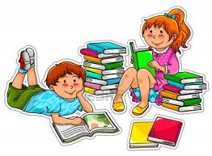
Students entering Kindergarten should read or be read ten or more books.
Print the attached chart, list the book title and color the books they are read and discussed at home. On the first day of school, students should turn in a picture illustrating one of the books they have read or been read and the completed log sheet.
Students are also encouraged to join the summer reading program at their parish library.

