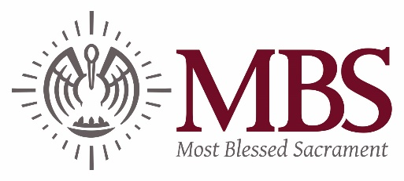
February 2019
Dear Parents,
The Louisiana Department of Revenue offers a tax deduction for fees paid to private schools.
Income Tax Deduction for Elementary and Secondary School Tuition (La. R.S. 47:297:10). www.revenue.louisiana.gov
Most Blessed Sacrament tuition and fees for the 2018-2019 school year were as follows:
Application
$75

Tuition PK-4
- $5800 for In-Parish Catholic Students
- $5,370 for Out-of-Parish Catholic Students
- $5,700 for Non-Catholic Students

Tuition K-8
- $4,875 for In-Parish Catholic Students
- $6,515 for Out-of-Parish Catholic Students
- $6,845 for Non-Catholic Students

Fees
- $350 Registration and Re-Registration
- $100 Tech Fee
- $75 PK4 Fee
- $25 K Fee
- $200 8th Grade Fee

Payments made in the 2018 calendar year can be deducted. Your cancelled checks, email confirmation or cash receipts given when tuition was paid will serve as your record of payment for this deduction. A statement for tuition paid in 2018 can be printed from your Smart Tuition Account.
Most Blessed Sacrament’s tax ID is 72-0884994.
If you have any questions, please contact Sarah Munn at smunn@mbsbr.org.
Sincerely,
Cheri M. Gioe, Principal

