6th ANNUAL HBCU

CLIMATE CHANGE

CONFERENCE

Preparing Tomorrow’s Leaders through Research & Action

**September 20 –23, 2018**

**New Orleans, LA**

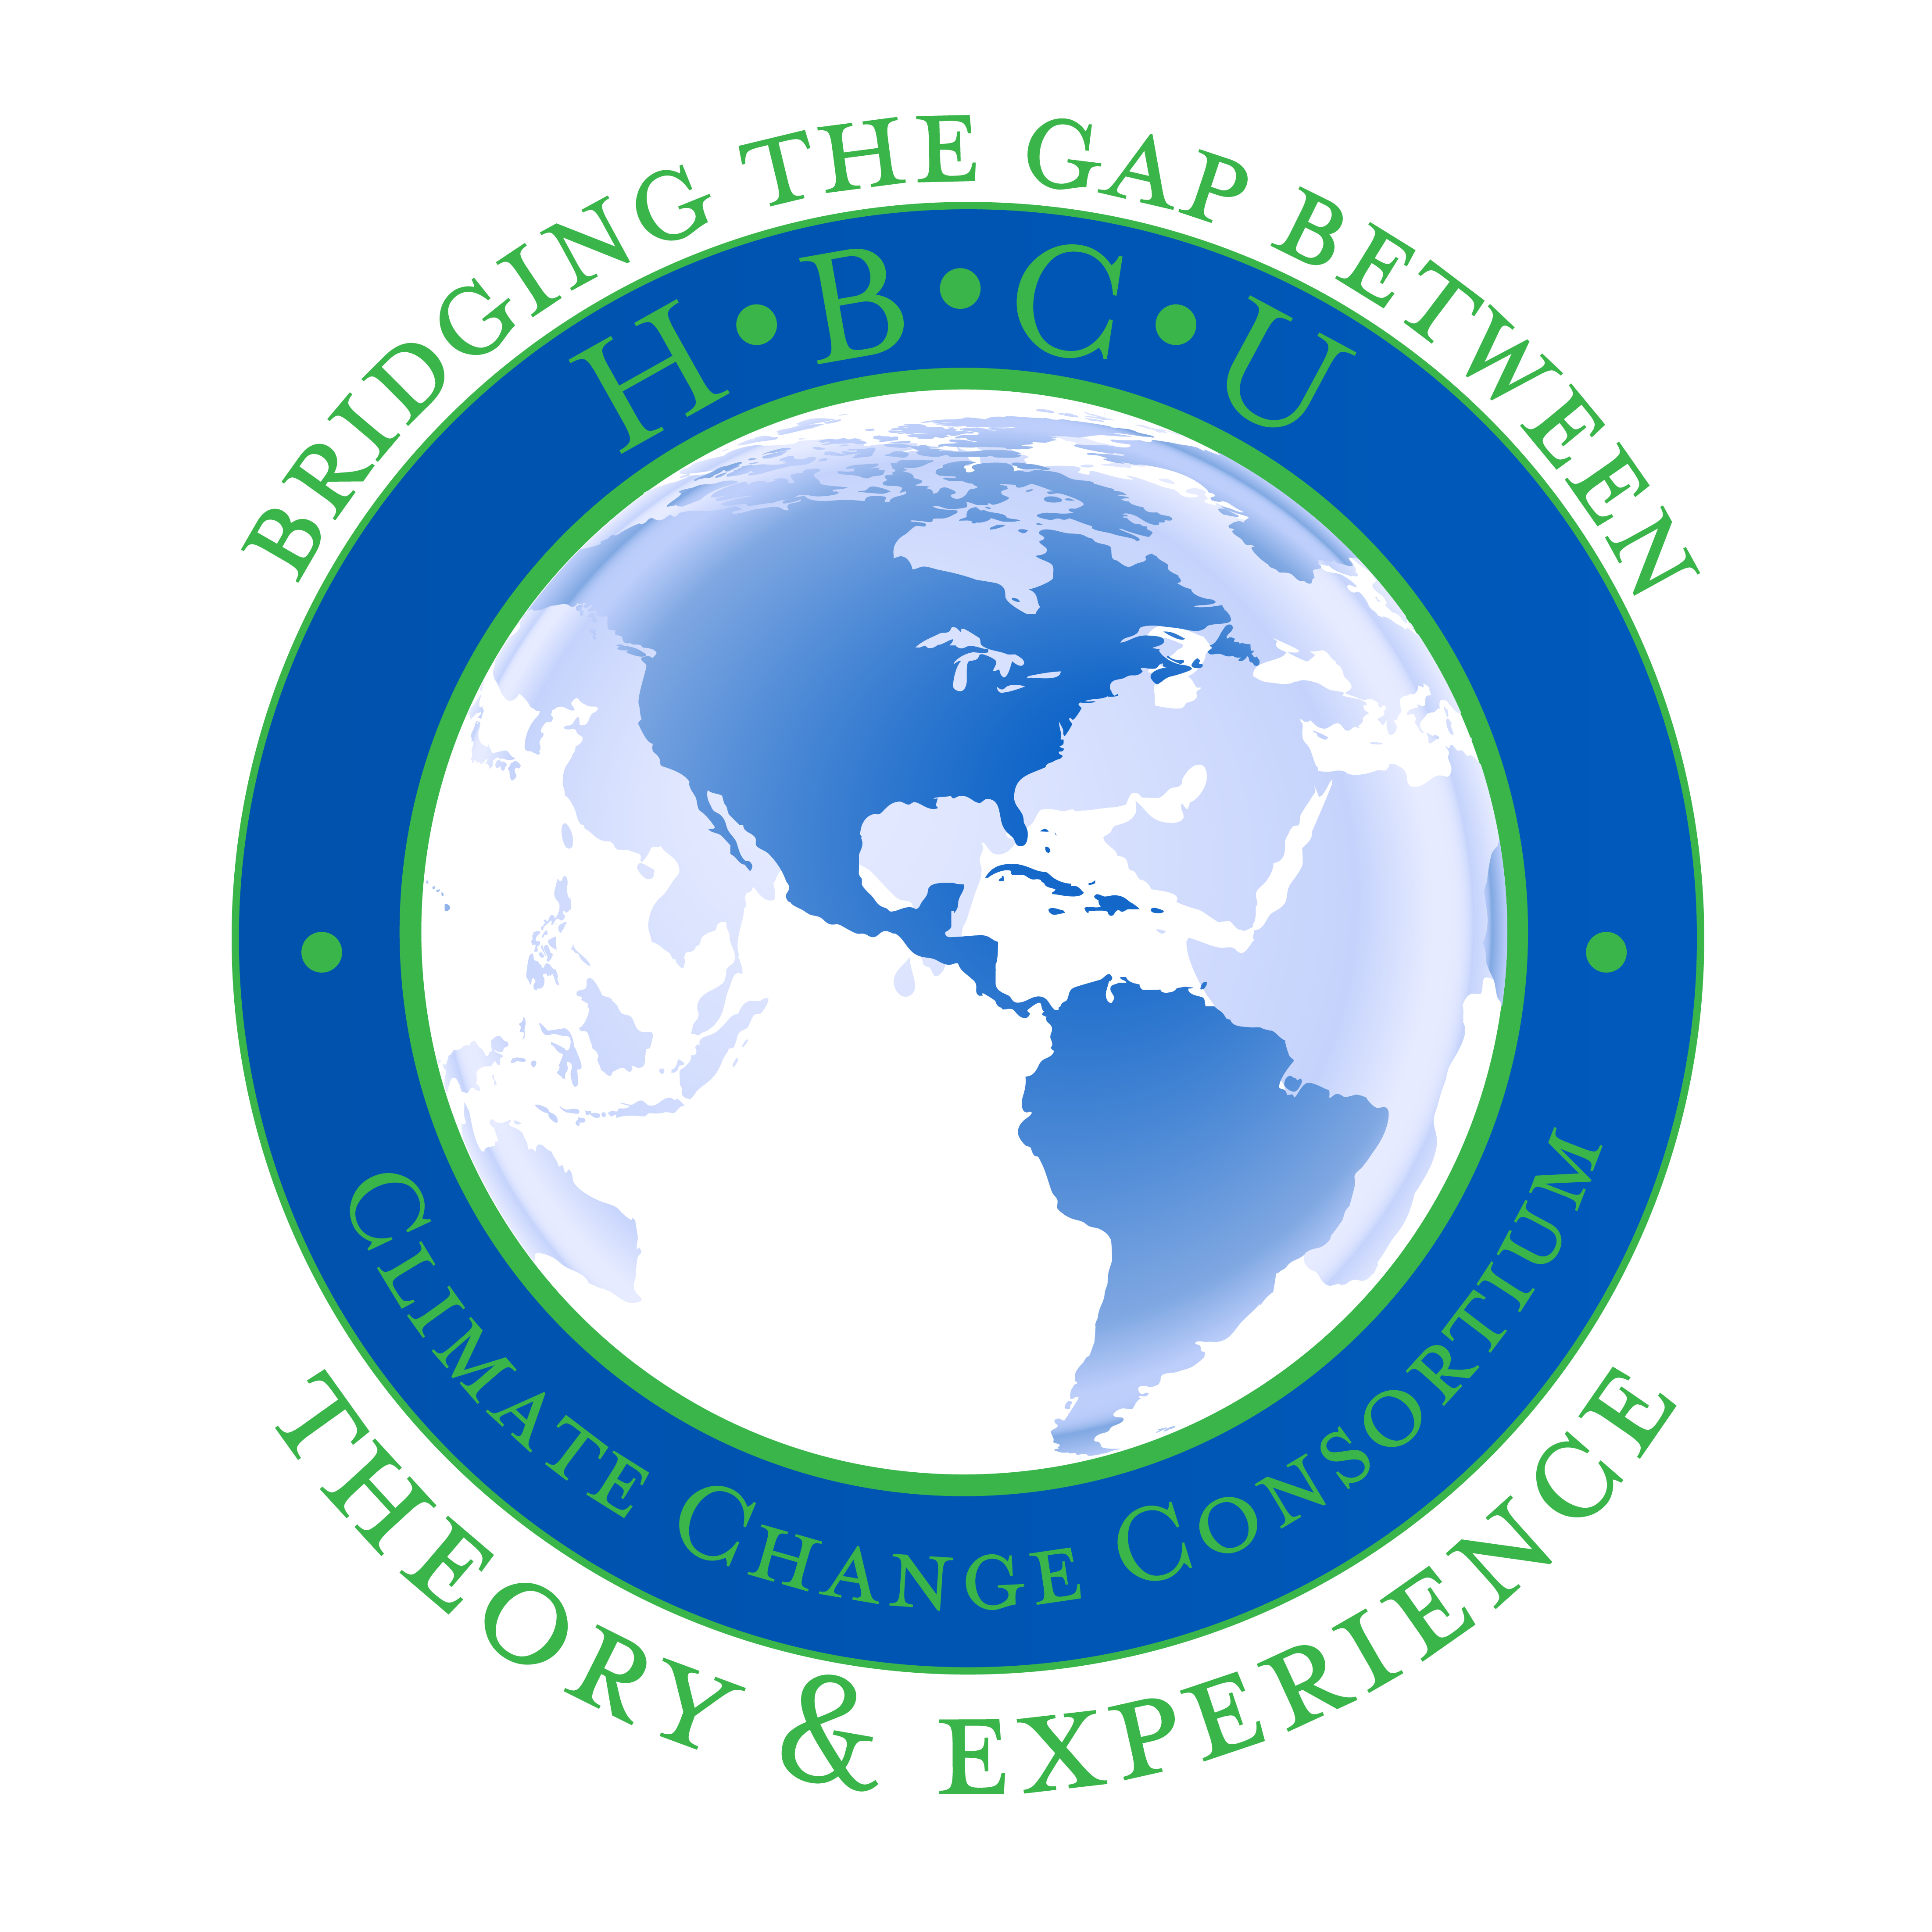

***A project of the HBCU Climate Change Consortium***

** Co-sponsors**











**HBCU**

**Climate Change Consortium Participating Institutions**

Alabama A&M University

Alabama State University

Alcorn State University

Arkansas Baptist College

Bethune-Cookman College

Claflin University

Clark Atlanta University

Coppin State University

Dillard University

Fisk University

Florida A & M University

Grambling State University

Hampton University

Howard University

Huston- Tillotson University

Jackson State University

Lincoln University

Mississippi Valley State University

Morehouse College

Morgan State University

North Carolina A &T University

Savannah State University

South Carolina State University

Southern A&M University Baton Rouge

Spelman College

Tennessee State University

Texas Southern University

Tuskegee University

Virginia State University

Xavier University of Louisiana

**Corresponding Institution**



Deep South Center for Environmental Justice

9801 Lake Forest Blvd.

New Orleans, LA 70127

(504) 272-0956 office

www.dscej.org

The Deep South Center for Environmental Justice and Texas Southern University is proud to present its ***6th Annual HBCU Climate Change Conference****. Our theme this year is* ***"Fighting for Our Lives."*** In our sixth year, the purpose of this conference is to (1) introduce HBCU students to climate change science, and (2) engage HBCU students with Gulf Coastal communities that are presently experiencing the impacts of climate change. The conference will continue the Consortium’s mission of *Preparing Tomorrow’s Leaders through Research and Action*.

Students at HBCUs are quite underrepresented in the climate change discourse and need opportunities to engage with researchers and scientists about the impacts of climate change. These students, many of whom are from disadvantaged communities, should be theoretically and experientially versed in the impacts that climate change could have on the communities where they live, work and study as well as in other cities. Our conference intends to offer such an experience.

A major objective of this conference is to cultivate in HBCU students a spirit of leadership and advocacy for climate-impacted communities and the social and environmental justice issues they face. Additionally, the education of HBCU students on topics related to climate change and justice will pave the way for them to become tomorrow’s leaders who will make sound choices and decisions positively affecting the future of our planet.

As our conference grows, it is of great importance that we secure complete funding for this initiative and gratefully acknowledge your organization’s commitment to the future of our world by investing in those who do not have ready access and input into the climate change discussion. Please return the sponsorship form with your payment as soon as possible. We thank you for your generosity.

Sincerely,

 

Beverly L. Wright, Ph.D. Robert Bullard, Ph.D.

Co-Convener Co-Convener

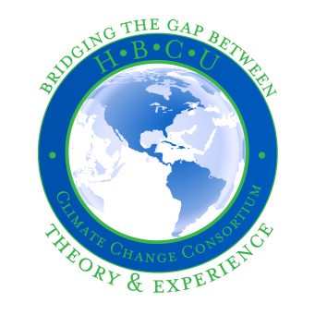

6th ANNUAL HBCU

CLIMATE CHANGE CONFERENCE

Preparing Tomorrow’s Leaders through Research & Action

**Executive Summary**

*Climate Change. Environmental Justice. Policy & Advocacy. Community Resilience & Sustainability.*

Dr. Beverly Wright of the Deep South Center for Environmental Justice and Dr. Robert Bullard, of Texas Southern University, started the HBCU Climate Change Initiative in 2011 to help raise awareness about the disproportionate impact of climate change on vulnerable and marginalized communities and to develop the next generation of leaders on issues related to environmental justice policies, community resilience, and adaptation.

It is a fact that students at Historically Black Colleges and Universities (HBCU) need opportunities to engage with researchers and scientists about the expected impacts of climate change. Most HBCUs are located in southern states – a vulnerable region impacted by hurricanes, drought, flooding, and other natural disasters. Climate-related disasters are increasing in the south more than other regions in the US. According to the *Federal Emergency Management Agency (FEMA)* Oklahoma, Texas, Louisiana, Arkansas, Tennessee, and Mississippi, were ranked within the top 15 most disaster declared states across the country, with 4 states being in the top 10. Studies show that climate change imposes the greatest health risks and biggest financial burden on people of color. The vast majority of the 105 HBCUs are located in southern states where intense hurricanes, drought, flooding, and other climate-sensitive hazards are commonplace.

As a project of the *HBCU Climate Change Consortium*, Drs. Wright and Bullard have conceptualized and implemented the **Annual HBCU Climate Change Conference** to provide opportunities for HBCU students from across the country to engage with Environmental Justice experts and communities, and to present the findings of their own research in this field. ***Since 2012, the Consortium has continued to expand these opportunities to reach more students at HBCUs***.

**How can you get involved?**

This year, we celebrate the **6th Annual of our HBCU Student Climate Change Conference: Bridging the Gap between Theory and Experience** with plans to draw over 300 attendees; from HBCU faculty mentors, students and EJ experts to environmental justice community leaders. We are reaching out to local, regional and national stakeholders to make this conference a success. The work of putting on such a conference comes with high costs, but the rewards are great! We are seeking conference sponsors who want to be instrumental in providing experiential learning opportunities to HBCU students while educating community members on climate change and environmental justice issues. Won’t you take advantage of this great opportunity to develop the next generation of leaders by participating at one of the sponsorship levels indicated in this packet? **Your participation will provide funds for travel, supplies and meeting expenses so that student and faculty participants from HBCUs across the country will be able to return to their schools and communities armed with valuable knowledge, experiences and the resolve to make a change.** We look forward to working together to bring this tremendous benefit to students, HBCUs and the communities they serve.

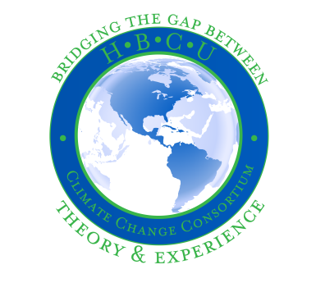

6th ANNUAL HBCU

CLIMATE CHANGE CONFERENCE

Preparing Tomorrow’s Leaders through Research & Action

Sponsor Name: ____________________________________________________________________________________________________

Company Name: __________________________________________________________________________________________________

Address: ___________________________________________________________________________________________________________

City/State/Zip: ____________________________________________________________________________________________________

Company Phone: _______________________ Email address: ________________________________________________________

Primary Sponsor Contact Name: ________________________________________________________________________________

Contact Phone: _________________________ Website address: _____________________________________________________

*Please send a digital file of your logo (300 dpi) to: maryw@dscej.org*

**Sponsor Level:** **Contribution:**

**Convener Sponsor $5,000; your amount: ____________**

*Includes recognition in the conference**program booklet; table exhibit, complementary conference registration for two (2) company employees and recognition during the conference.*

**Partner Sponsor $2,500; your amount: ____________**

*Includes recognition in the conference program booklet; table exhibit, and conference registration for two (2) company employees.*

**Advocate Sponsor $1,500; your amount: _____________**

*Includes recognition in the conference program booklet; table exhibit; and complimentary conference registration for one (1) company employee.*

**Friend of the Conference $500; your amount: ___________**

*Your organization will be listed in the conference program booklet.*

**Please make checks payable to:**

Deep South Center for Environmental Justice

**Mail check to: Questions?**

Deep South Center for Environmental Justice Please contact us at:

9801 Lake Forest Blvd. maryw@dscej.org

New Orleans, LA 70127 Phone (504) 510-2991