DATE  Your cafeteria is managed by  Canteen of Central New Mexico an equal opportunity employer | Monday | Tuesday | Wednesday | Thursday | Friday
12/21 1/18 /15 3/15 4/12 5/10 | PAPA JOHNS PIZZA (1EA)  VEG.-BROCCOLI (3/4 cp)  FRUIT-MIXED FRUIT (1/2cp)  GRAIN-INCLUDED IN ENTREE  RANCH DRESSING (1oz)  MILK (8OZ-1EA) | FRESH BEEF TACO (2oz)  VEG.-PINTO BEANS (3/4 cp)  FRUIT-CANTALOUPE (1EA)  GRAIN-TORTILLA (1EA)  SHREDDED CHEESE (1oz)  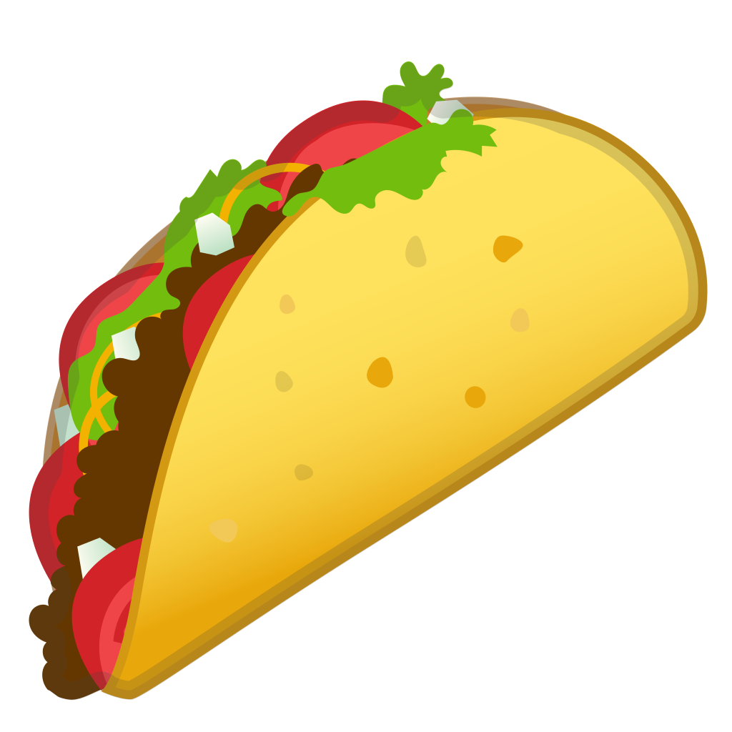  MILK (8OZ-1EA) | CORN DOG (1EA)  VEG.-MIXED VEGGIES (3/4cp)  FRUIT-CINN. APPLE (1/2cp)  GRAIN-INCLUDED IN ENTREE  KETCHUP, MUSTARD(1oz)  MILK (8OZ-1EA) | CHICKEN FRIED STEAK (1EA)  VEG.-MASHED POTATOES (3/4 cp)  FRUIT-PEACHES (1/2 cp)  GRAIN- BISCUIT (1EA)  MILK (8OZ-1EA) | CHICKEN FAJITAS (1/4CP)  VEG.-CARROTS (3/4 cp)  FRUIT-APPLE (1EA)  GRAIN-TORTILLA  PICANTE (1oz)  MILK (8OZ-1EA)
12/28 1/25 2/22 3/22 4/19 5/17 | CHEESEBURGER (1EA, 1 SLICE CHEESE)  VEG.-BAKED BEANS (3/4 cp)  FRUIT-MIXED FRUIT (1/2cp)  GRAIN-HAMBURGER BUN (1EA)  MUSTARD, KETCHUP, PICKLES (1oz)  MILK (8OZ-1EA) | SPAGEHETTI (3/4 cp)  VEG.-BROCCOLI (3/4 cp)  FRUIT-FRESH FRUIT (1EA)  GRAIN-BREADSTICK  MILK (8OZ-1EA) | FETTUCCINI CHICKEN ALFREDO (3/4CP)  VEG.-CARROTS (3/4 cp)  FRUIT-MANDARIN ORANGES (1/2 cp)  GRAIN- BREAD STICK (1EA)  MILK (8OZ-1EA) | CHEESE STICKS (2EA)  VEG.-MIXED VEGGIES (3/4cp)  FRUIT-PEARS (1/2 cp)  GRAIN- INCLUDED IN ENTRÉE  MARINARA SAUCE (1OZ)  MILK (8OZ-1EA) | CHICKEN NUGGETS (5EA)  VEG.-POTATO WEDGES (3/4 cp)  FRUIT-ORANGE (1EA)  GRAIN-ROLL (1EA)  KETCHUP (1oz)  MILK (8OZ-1EA)
1/4 2/1 3/1 3/29 4/26 5/24 | PAPA JOHNS PIZZA (1EA)  VEG.-CARROTS (3/4 cp)  FRUIT-PINEAPPLE (1/2 cp)  GRAIN-INCLUDED IN ENTREE  RANCH (1oz)  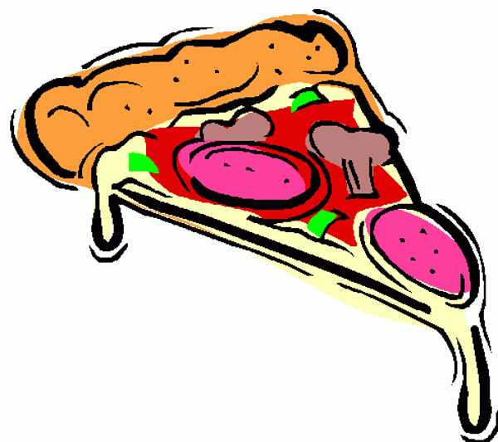  MILK (8OZ-1EA) | FRITO PIE (2oz, CHIPS 1oz)  VEG.-CORN (3/4 cp)  FRUIT-MANDARIN ORANGES (1/2 cp)  GRAIN-TORTILLA (1EA)  SHREDDED CHEESE (1oz)  MILK (8OZ-1EA) | HOT DOG (1EA)  VEG.-CELERY (3/4 cp)  FRUIT-MIXED FRUIT (1/2cp)  GRAIN- BUN (1EA)  KETCHUP (1oz)  MILK (8OZ-1EA) | BOW TIE LASAGNA (3/4CP)  VEG.-BROCCOLI (3/4 cp)  FRUIT-APPLESAUCE (1/2cp)  GRAIN-GARLIC BREADSTICK (1EA)  MILK (8OZ-1EA) | CRISPY CHICKEN  SANDWICH (1EA)  VEG.-BAKED BEANS (3/4cp)  FRUIT-PEACHES (1/2 cp)  GRAIN-HAMBURGER BUN (1EA)  MILK (8OZ-1EA)
1/11 2/8 3/8 4/5 5/3 5/31 | MAC AND CHEESE (3/4 cp)  VEG.-BROCCOLI (3/4 cp)  FRUIT-PEACHES (1/2 cp)  GRAIN- ROLL (1EA)  MILK (8OZ-1EA) | SOFT CHICKEN TACO (2oz)  VEG.-PINTO BEANS (3/4 cp)  FRUIT-ORANGE (1EA)  GRAIN-TORTILLA (1EA)  SHREDDED CHEESE (1oz)  PICANTE SAUCE (1oz)  MILK (8OZ-1EA) | SALISBURY STEAK (1EA)  VEG.-WHIP POTATOES (3/4cp)  FRUIT-MIXED FRUIT (1/2cp)  GRAIN-DINNER ROLL (1EA)  BROWN GRAVY (1oz)  MILK (8OZ-1EA)  **HIGH SCHOOL PORTION SIZE 1 CUP** | GRILLED CHEESE (1EA)  VEG.-CARROTS (3/4 cp)  FRUIT-FRESH FRUIT (1EA)  GRAIN-INCLUDED IN ENTRÉE  MILK (8OZ-1EA) | BEAN BURRITO (1EA)  VEG.-GREEN BEANS (3/4cp)  FRUIT-MANDARIN ORANGES (1/2 cp)  GRAIN-INCLUDED IN ENTREE  PICANTE SAUCE (1oz)  MILK (8OZ-1EA)
LUNCH MENU 2020-2021

